Article type
(Research article, Review, Short communication, Discussion, etc.)

Title
(Title usually falls within 2−3 lines. All words, except for proper nouns, should be in lowercase.)

First name Last nameª, First name Last name^{b}, First name Last name^{b,}*
ª Department of xxx, School of Economics and Finance, Xi’an Jiaotong University, Xi’an, 710049, China;
^{b} Department of xxx, Institute of Transport and Logistics Studies, The University of Sydney Business School, The University of Sydney, NSW 2006, Australia
(Author affiliations should be listed according to the name order under the paper title. The corresponding author should be marked with “*” on the top right.)

* Corresponding author.
E-mail address: e-mail@e-mail.com (author initials).
Abstract
(Abstract should be about 150−200 words which can conclude the whole content of the paper, including purpose, method, results and conclusion. Equations, figures and tables, as well as references are not supposed to appear in this part. When abbreviation is firstly used, it should contain the full name with its abbreviation included in parentheses, such as “mixed multinominal logit (MMNL) model”. Do NOT use the first person as subject. Do NOT repeat the title as the first sentence of the abstract. Simple sentence and active voice are preferred, and verb should be close to the subject.)
This study conducts an experimental analysis of risky travel choice behaviour, while accounting for the trade-off between attributes, nonlinearity in utility specification and perceptual conditioning. The focus is on empirically measuring between-individual heterogeneity in beliefs, and a key finding is that the sampled decision makers are associated with different levels of pessimism. The accommodation of individual beliefs in modelling risky decisions contributes significantly to the explanation of the choice data, relative to the normative Expected Utility Theoretical model which directly uses the probabilities of outcomes and implicitly assumes belief neutrality. The implication of pessimistic beliefs for valuing willingness to pay is illustrated at the individual level.
Keywords: Decision making under risk; Choice behaviour; Belief; Willingness to pay; Rank-Dependent Utility Theory
(about 5-8 words separated with “;”; use small letters except technical terms. Abbreviations should contain full name with abbreviation included in parentheses.)

1. Introduction
Choice situations may be deterministic or probabilistic. In the former (latter) choice domain, the attribute levels of a choice alternative tend to be constant (variable) over repeated experiences. For road transport systems, in particular operating in urban areas, variations of travel time are inevitable due to fluctuations at the demand side and supply side of traffic.
Most conventional travel time variability research simply treated travel time variability as an additional component of disutility within a linear utility modelling framework (Taylor, 2013), while ignoring the psychological influence of risk on decision making.
(Equations, figures and tables are usually not supposed to appear in this part.)

2. Material and methods
2.1．
2.2．
2.2.1．
2.2.2．

3. Theory/calculation
3.1．
3.1.1．
3.1.2．
3.2．

4. Results
4.1．
4.2．
4.2.1．
A detailed guide on electronic artwork is available on our website:
http://www.elsevier.com/artworkinstructions
You are urged to visit this site; some excerpts from the detailed information are given here.
Formats
Regardless of the application used, when your electronic artwork is finalised, please "save as" or convert the images to one of the following formats (note the resolution requirements for line drawings, halftones, and line/halftone combinations given below):
EPS: Vector drawings. Embed the font or save the text as "graphics".
TIFF: color or grayscale photographs (halftones): always use a minimum of 300 dpi.
TIFF: Bitmapped line drawings: use a minimum of 1000 dpi.
TIFF: Combinations bitmapped line/half-tone (color or grayscale): a minimum of 500 dpi is required.
If your electronic artwork is created in a Microsoft Office application (Word, PowerPoint, Excel) then please supply "as is".
Please do not:
• Supply files that are optimized for screen use (like GIF, BMP, PICT, WPG); the resolution is too low;
• Supply files that are too low in resolution;
• Submit graphics that are disproportionately large for the content.
Color artwork
Please make sure that artwork files are in an acceptable format (TIFF, EPS or MS Office files) and with the correct resolution. If, together with your accepted article, you submit usable color figures then Elsevier will ensure, at no additional charge, that these figures will appear in color on the Web (e.g., ScienceDirect and other sites) regardless of whether or not these illustrations are reproduced in color in the printed version.
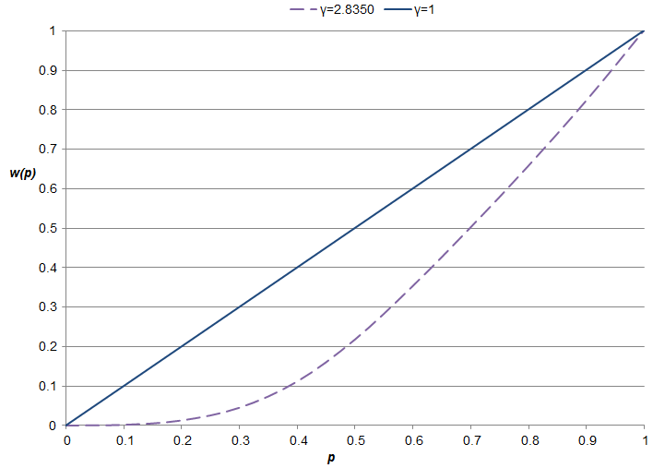
Fig. 2. Non-linear probability weighting function.

Table 1. The AS_EEUT MMNL model (assuming belief neutrality).
 | Variable |  | Coefficient |  | t-Ratio
Nonrandom parameters:
Reference constant |  | 0.6406 |  | 4.51
Cost ($) |  | −0.3887 |  | −9.62
Tollasc |  | −0.4259 |  | −2.65
Age (years, reference (first) alternative only) |  | 0.0174 |  | 6.25
Means for random parameters:
Alpha (α) |  | 0.7174 |  | 94.94
Probability weighted travel time (minutes) |  | −1.3095 |  | −47.22
Standard deviations for random parameters:
Alpha (α) |  | 0.3444 |  | 25.94
Probability Weighted Travel Time (minutes) |  | 1.3095 |  | 47.22
No. of observations |  | 4,480
McFadden Pseudo R-squared |  | 0.419
Log-likelihood |  | −2,858.15

All parameter estimates are statistically significant at the 99 percent confidence level. The two models offer some similar findings. For example, the estimated parameters for the reference specific constant are positive, which suggests, after accounting for the observed influences, that sampled respondents, on average, prefer their current trip relative to the two stated choice alternatives.

5. Discussion
5.1.
5.2.
Willingness to pay is an important output of multi-attribute choice studies. Under the AS_ERDUT model, the WTP formula is given in Eq. (8), which takes the transformed probabilities of the travel time distribution (in this study the decision weights of late, early and on-time arrival). Instead of treating mean travel time and variability separately, this WTP value, referred to as the value of decision-weight weighted travel time savings (VDWWTTS).

6. Conclusions
(Conclusion should be summarized in points without tedious description of background, method, etc.)
For the generalisability of the experimental outputs, Loomes and Pogrebna (2014), Zhou and Hey (2018), among others, highlight that researchers need to design experiments with the similar contexts as the real-world decision problems under investigation and elicit economic/psychological elements that best explain behaviour in that specific situation. This study used a choice experiment, which is close to the real-market settings and established on the recent travel experiences of sampled car commuters where two SP alternatives were pivoted around their knowledge.

Declaration of competing interest
The authors declare that there are no conflicts of interest.

Acknowledgments
The authors would like to acknowledge the National Natural Science Foundation of China (Grant No.: xxxxxx), Open Foundation of Hypervelocity Impact Research Center of CARDC (Grant No.: 20180201) and Open Project of State Key Laboratory of Explosion Science and Technology in Beijing Institute of Technology (Grant No.: xxxxxx) to provide fund for conducting experiments.

References
Cite references appropriately and ensure every citation is relevant with the reference, avoiding redundancy and excessive self-citation to maintain the scientific integrity of your article.

Reference citing in the manuscript: author-date format
Single author: the author’s name (without initials, unless there is ambiguity) and the year of publication;
Two authors: both authors’ names and the year of publication;
Three or more authors: first author’s name followed by ‘et al.’ and the year of publication.

Citations may be made directly (or parenthetically). Groups of references should be listed first alphabetically, then chronologically.

Examples:
as demonstrated (Allan, 1996a, 1996b, 1999; Allan and Jones, 1995)
Kramer et al. (2000) have recently shown...

List of References at the end of the manuscript should be arranged first alphabetically and then further sorted chronologically if necessary. More than one reference from the same author(s) in the same year must be identified by the letters “a”, “b”, “c”, etc., placed after the year of publication.

Reference to a journal publication (Journal names should be abbreviated, but if you are uncertain, keep it in full name)
Journal abbreviations source
Journal names should be abbreviated according to
List of title word abbreviations: http://www.issn.org/2-22661-LTWA-online.php

If there are more than three authors, please list only the first three authors followed by “et al.”

Reference to a journal publication:
Peters, G.F., Romi, A.M., 2014. Does the voluntary adoption of corporate governance mechanisms improve environmental risk disclosures? Evidence from greenhouse gas emission accounting. J. Bus. Ethics 125 (11), 637–666.
(Note: Volume and issue information is required.)
Reference to a journal publication with an article number:
Gordon, B., Fennessy, C., Varma, S., et al., 2022. Evaluation of freely available data profiling tools for health data research application: a functional evaluation review. BMJ Open 12 (5), e054186.
Reference to a book:
Strunk Jr., W., White, E.B., 2000. The Elements of Style, fourth ed. Longman, New York.
Reference to a chapter in a book:
Mettam, G.R., Adams, L.B., 2023. How to prepare an electronic version of your article, in: Jones, B.S., Smith, R.Z. (Eds.), Introduction to the Electronic Age. E-Publishing Inc., New York, pp. 281–304.
Reference to a website:
Cancer Research UK, 2023. Cancer statistics reports for the UK. http://www.cancerresearchuk.org/aboutcancer/statistics/cancerstatsreport/ (Accessed 13 March 2023).
Reference to a dataset:
Oguro, M., Imahiro, S., Saito, S., et al., 2015. Mortality data for Japanese oak wilt disease and surrounding forest compositions [dataset]. Mendeley Data, v1.
Reference to software:
Coon, E., Berndt, M., Jan, A., et al., 2020. Advanced Terrestrial Simulator (ATS) v0.88 (Version 0.88) [software]. Zenodo.
Reference to a thesis/dissertation:
Enearu, W.O., 2020. The impact of leadership styles on employee engagement in small and medium enterprises [master’s thesis]. National College of Ireland, Dublin.
Ajayi, O.A., 2025. Implementing environmental, social, and governance (ESG) principles in organizations: the role of leadership and impacts on corporate financial performance [dissertation]. Case Western Reserve University, Cleveland.
Reference to a conference paper:
Pan, F., Bent, R., Berscheid, A., et al., 2010. Locating PHEV exchange stations in
v2g. In: 2010 First IEEE International Conference on Smart Grid Communications.
IEEE, pp. 173–178.
Reference to an article in preprint:
Alom, M.Z., Taha, T.M., Yakopcic, C., et al., 2018. The history began from Alexnet: a comprehensive survey on deep learning approaches. ArXiv.1803.01164.

Appendix A. Supplementary data
Supplementary data to this article can be found online at http://doi/org/...

